**Name : Maiyani Gautam Sureshbhai**

**Branch : CSE**

**Sub : DBMS**

**Seat No : 312025**

**Batch : Y-batch**

**Prn : 2020033800100853**

**E-mail :** [**gautammaiyani2332@gmail.com**](mailto:gautammaiyani2332@gmail.com)

**Mob. No: 9067548332**

**PART-1**

**TEAM_MASTER (TEAM_ID, TEAM,NAME)**

**PLAYER(TEAM_ID, PID, PNAME, PBIRTHDATE)**

**SCORE(TEAM_ID, PID, RUNS_MADE, OUT_TYPE, B_ID, BTEAM_ID)**

**BALLING (TEAM_ID, B_ID, OVERS, MAIDEN, RUNS_GIVEN, WICKETS_TAKEN)**

1. Write DDLs to create the above table with necessary constraints.

create table Team_Master(

team_id number(5) constraint pk_team_id primary key ,

team_name varchar2(20)

); desc Team_Master

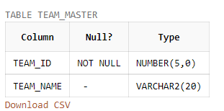

create table Player(

team_id number(5),

pid number(5),

pname varchar2(30),

pbirthdate date,

constraint fk_team_id foreign key(team_id) references Team_Master(team_id) on delete cascade ,

constraint pk_team_id_pid primary key(team_id,pid)); desc Player

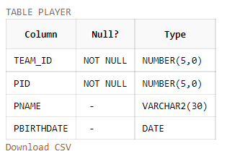

create table Score(

team_id number(5),

pid number(5),

runs_made number(5),

out_type varchar2(20),

bid number(5),

bteam_id number(5),

constraint fk1_team_id_pid foreign key(team_id,pid) references Player(team_id,pid) ,

constraint fk2_bteam_id_bid foreign key(bteam_id,bid) references Player(team_id,pid) ,

constraint pkS_team_id_pid primary key(team_id,pid) ); desc Score

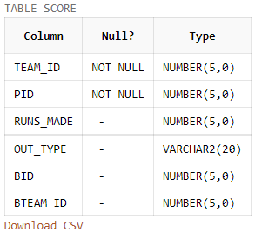

create table Balling(

team_id number(5),

bid number(5),

overs number(10),

maiden number(5),

runs_given number(5),

wickets_taken number(10),

constraint fk_team_id_bid foreign key(team_id,bid) references Player(team_id,pid),

constraint pk_team_id_bid primary key(team_id,bid)); desc Balling

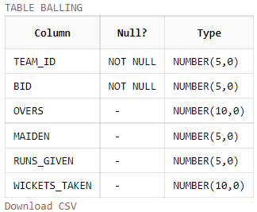

insert into Team_Master values(101,'India');

insert into Team_Master values(102,'Australia');

insert into Team_Master values(103,'England');

insert into Team_Master values(104,'SouthAfrica');

insert into Team_Master values(105,'WestIndies');

Select * from Team_Master;

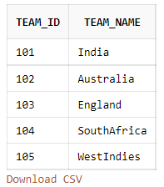

insert into Player values(101,1,'MS Dhoni',to_date('07-07-1981','dd-mm-yyyy')) ;

insert into Player values(101,2,'Virat Kohli',to_date('05-11-1988','dd-mm-yyyy')) ;

insert into Player values(101,3,'Ravindra Jadeja',to_date('06-12-1988','dd-mm-yyyy'))

insert into Player values(102,1,'Steve Smith',to_date('01-11-1988','dd-mm-yyyy')) ;

insert into Player values(102,2,'David Warner',to_date('08-12-1984','dd-mm-yyyy')) ;

insert into Player values(102,3,'Glen Johnsen',to_date('21-09-1995','dd-mm-yyyy')) ;

insert into Player values(103,1,'Eion Morgan',to_date('17-04-1982','dd-mm-yyyy')) ;

insert into Player values(103,2,'Ben Stokes',to_date('20-02-1989','dd-mm-yyyy')) ;

insert into Player values(103,3,'Moin Ali',to_date('18-06-1987','dd-mm-yyyy')) ;

insert into Player values(104,1,'Michel Starks',to_date('22-06-1983','dd-mm-yyyy')) ;

insert into Player values(104,2,'AB de Villiers',to_date('15-02-1987','dd-mm-yyyy')) ;

insert into Player values(105,1,'Bravo',to_date('10-07-1988','dd-mm-yyyy')) ;

insert into Player values(105,2,'Chris Gayle',to_date('10-01-1979','dd-mm-yyyy')) ;

select * from Player;

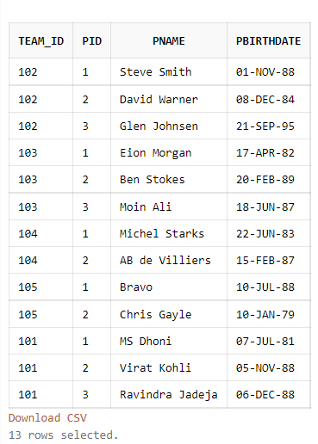

insert into Score values(101,1,101,'Bowled',2,103) ;

insert into Score values(101,2,79,'Caught',1,105) ;

insert into Score values(101,3,34,'Caught',2,103) ;

insert into Score values(102,1,36,'Stumped',3,103) ;

insert into Score values(102,2,5,'LBW',2,105) ;

insert into Score values(103,1,44,'Caught',1,105) ;

insert into Score values(104,1,68,'Stumped',1,105) ;

insert into Score values(104,2,23,'Caught',2,103) ;

Select *from Score;

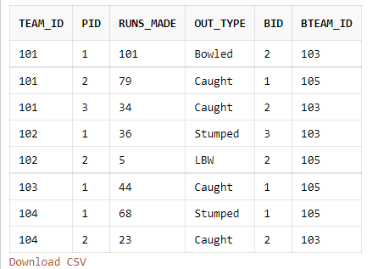

insert into Balling values(103,2,4,0,28,2);

insert into Balling values(105,1,4,0,22,2);

insert into Balling values(103,3,3,0,36,0);

insert into Balling values(105,2,4,1,45,1);

insert into Balling values(102,3,2,0,22,0);

insert into Balling values(101,3,4,1,21,4);

Select *from Balling;

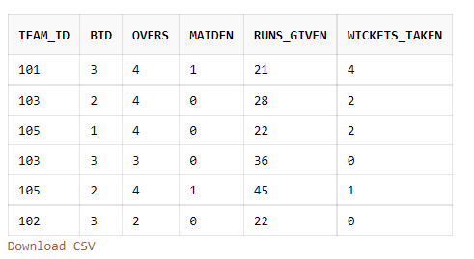

1. Display details about the bowler who took the maximum wickets.

select * from Balling where wickets_taken = (select max(wickets_taken) from Balling);

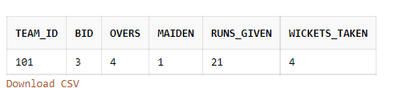

1. Which players are born in the month of February and have scored more than 25 runs?

select * from Player where pid in (select pid from Score where runs_made > 25) and (to_char(pbirthdate,'Mon') = 'Feb') ;

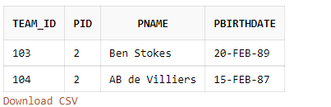

1. Display details about players who bowled at the most three maiden overs.

select p.team_id,pid,pname as Name,overs,maiden,runs_given as Run,wickets_taken as Wickets from Player p , Balling b where p.pid = b.bid and p.team_id = b.team_id and maiden <= 3 ;

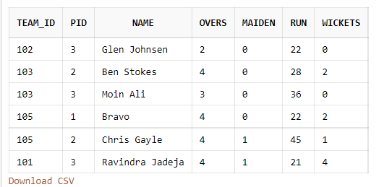

1. Display the total runs given by each bowler.

select p.team_id,bid,pname as Name,runs_given as Runs from Player p , Balling b where p.pid = b.bid and p.team_id = b.team_id ;

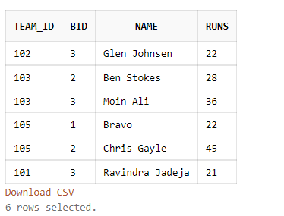

1. Display team wise how many players got out with lbw, stumping, catch etc.

select team_id,out_type,count(*) as count from Score group by (team_id,out_type) order by team_id ;

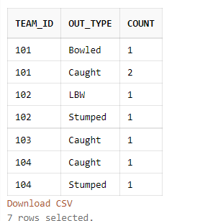

1. Display details about players who are more than 40 years old.

select * from Player where round(sysdate-pbirthdate) > 40*365;

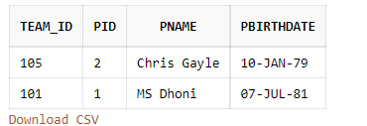

1. Display the bowlers who are also batsmen.

select p.team_id, p.pid, pname as “ALL ROUNDERS” from Player p,Score s , Balling b where s.pid=b.bid and s.team_id=b.team_id and p.pid=s.pid and p.team_id=s.team_id ;

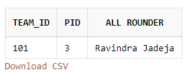

**PART-2**

**CANDIDATE (CID, CNAME, CADDRESS, CBIRTH_DT)**

**TEST (TID, TNAME, TOT_MRKS, PASS_MKS)**

**TEST_CENTRE (TCID, LOCATION, MGR, CAPACITY)**

**TEST_TAKEN (CID, TID, TCID, TEST_DT, SCORE)**

1. Design the above tables with appropriate constraints.

create table Candidate(

cid number(5) constraint pk_cid primary key,

cname varchar2(25),

caddress varchar2(30),

cbirth_dt date );

create table Test(

tid number(5) constraint pk_tid primary key,

tname varchar2(25),

tot_marks number(5),

pass_marks number(5) constraint ck_pm check(pass_marks < tot_marks));

create table Test_Centre(

tcid number(5) constraint pk_tcid primary key,

location varchar2(25),

mgr varchar2(25),

capacity number(5) );

create table Test_Taken(

cid number(5),

tid number(5),

tcid number(5),

test_dt date,

score number(5),

constraint fk_cid foreign key(cid) references candidate(cid),

constraint fk_tid foreign key(tid) references test(tid),

constraint fk_tcid foreign key(tcid) references test_centre(tcid),

constraint pk_cid_tid_tcid primary key(cid,tid,tcid));

* INSERTING VALUE IN TABLE

insert into Candidate values(1,'Gautam Maiyani','Kirti Stambh','14-Nov-2002');

insert into Candidate values(2,'Raval Krish ','Akota','07-JUN-2001');

insert into Candidate values(3,'Roy Makwana','Alkapuri','07-FEB-2003');

insert into Candidate values(4,'Mayank Trivedi','Gotri','12-JAN-2001');

insert into Candidate values(5,'Tirth Shah','Akota','24-JAN-2001');

insert into Candidate values(6,'Raj Patel','Karelibaugh','01-JUN-2002');

select * from Candidate;

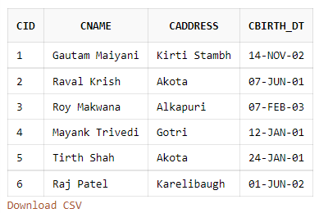

insert into test values(1,'JEE Mains',360,100) ;

insert into test values(2,'JEE Advanced',480,120) ;

insert into test values(3,'NEET UG',720,360) ;

insert into test values(4,'GUJCET',120,40) ;

SELECT* from test;

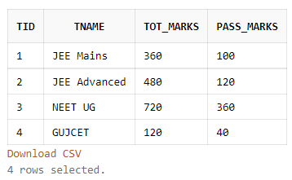

insert into Test_Centre values(1,'Gotri','Raj Shah',200) ;

insert into Test_Centre values(2,'Alkapuri','Nilesh Patel',100) ;

insert into Test_Centre values(3,'Manjalpur','Nikita Parmar',150) ;

insert into Test_Centre values(4,'Karelibaugh','Henil Shah',230) ;

insert into Test_Centre values(5,'Akota','Mayur Desai',270) ;

insert into Test_Centre values(6,'GIDC','Amit Shah',110) ;

SELECT* from Test_Centre;

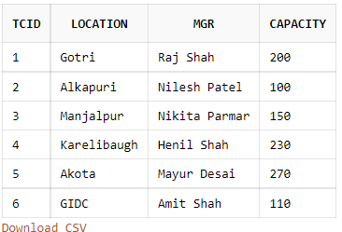

insert into Test_Taken values(1,1,4,'15-JUNE-2020',220);

insert into Test_Taken values(1,2,4,'20-MAY-2020',155);

insert into Test_Taken values(1,4,1,'20-APR-2020',118);

insert into Test_Taken values(2,3,2,'25-JUNE-2020',580);

insert into Test_Taken values(3,3,2,'20-MAY-2020',490);

insert into Test_Taken values(4,1,1,'20-APR-2020',120);

insert into Test_Taken values(4,2,4,'15-MAY-2020',25);

insert into Test_Taken values(4,4,3,'25-APR-2020',99);

insert into Test_Taken values(5,1,2,'20-APR-2020',100);

insert into Test_Taken values(5,4,2,'25-APR-2020',70);

insert into Test_Taken values(6,1,1,'20-APR-2020',200);

insert into Test_Taken values(6,2,3,'15-MAY-2020',180);

SELECT* from Test_Taken;

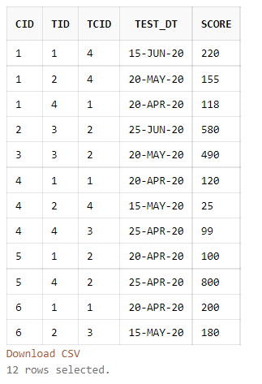

1. Display the number of candidates who have appeared for each test at each test centre.

select tt.tid, tname, tt.tcid, location, count(*) as No_Of_Candidates from Test_Taken tt , Test t,Test_Centre tc where tt.tid = t.tid and tt.tcid = tc.tcid group by(tt.tid,tt.tcid,tname,location) order by(tid);

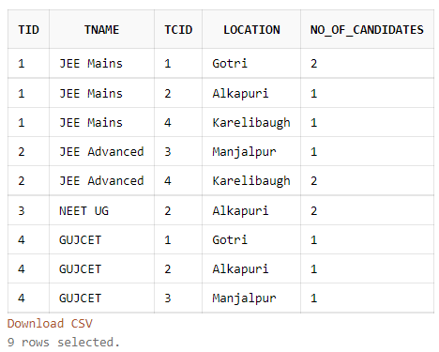

1. Display candidate details for those candidates who have scored as many marks as Vineet for tests conducted at Manjalpur.

select c.* from Candidate c ,Test_Centre tc, Test_Taken tt where c.cid = tt.cid and tc.tcid = tt.tcid and upper(location) = 'MANJALPUR' and score in (select score from test_taken tt1 ,Candidate c1 where tt1.cid = c.cid and upper(cname) = 'RAJ PATEL') ;

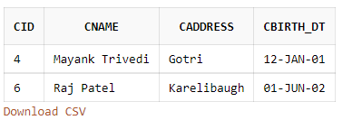

1. Display details about test centers where no tests have been conducted.

select * from Test_Centre where tcid not in (select distinct(tcid) from Test_Taken ) order by tcid ;

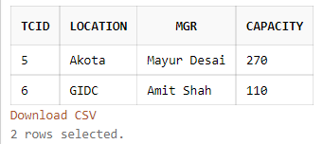

1. Display details of candidates who have failed**.**

select c.cid, c.cname, t.tname, t.pass_marks, tt.score from Candidate c , Test_Taken tt ,Test t

where c.cid = tt.cid and t.tid = tt.tid and score < pass_marks ;

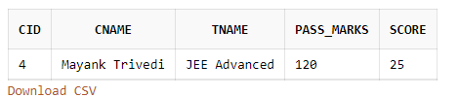

1. For tests, which have been conducted between 20-04-2020 and 15-05-2020, show details of the tests as well as the test centers.

select tt.tid, t.tname, tt.tcid, tc.location, test_dt from Test_Centre tc, Test_Taken tt, Test t where tc.tcid = tt.tcid and t.tid = tt.tid and test_dt between '20-APR-2020' and '15-MAY-2020' group by (t.tname, tt.tid, tt.tcid, tc.location, test_dt) order by tt.tid,tt.tcid ;

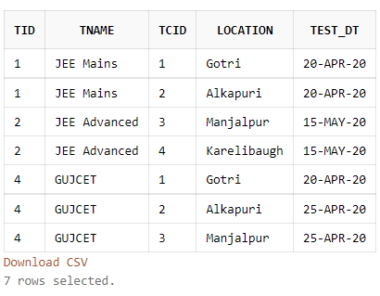

1. How many candidates appeared in the ‘JEE MAINS’ test at Surat in the month of April?

select count(*) as No_Of_Cand from Test_Taken where to_char(test_dt,'Mon')='Apr' and tid in (select tid from Test where upper(tname) = 'JEE MAINS') and tcid = (select tcid from Test_Centre where upper(location) = 'GOTRI') group by tid ;

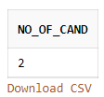

1. Display details about candidates who appeared for tests in the same month as the month in which they were born.

select * from Candidate where cid in (select c.cid from Candidate c ,Test_Taken tt where tt.cid = c.cid and to_char(cbirth_dt,'Mon') = to_char(test_dt,'Mon')) ;

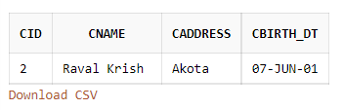

1. Display the details about candidates who have scored the highest in each test, test centre wise.

select * from candidate where cid in (select cid from test_taken where (score,cid,tid,tcid) in (select max(score),cid,tid,tcid from test_taken group by (score,cid,tid,tcid))) ;

